
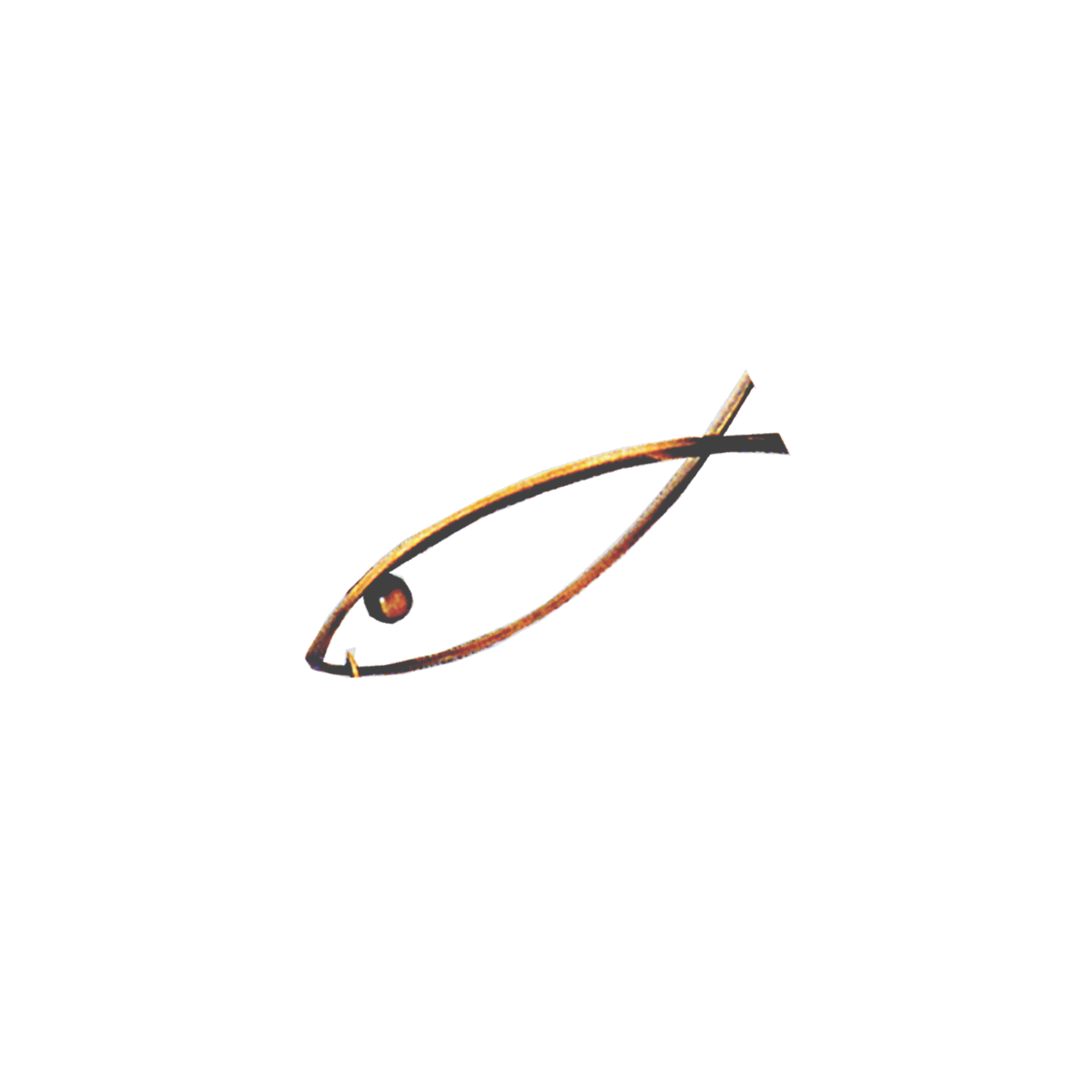

FIPSed

OFFICIAL F.I.P.S.e.d. RULES
FÉDÉRATION INTERNATIONALE
DE LA PÊCHE SPORTIVE EN EAU DOUCE

CONCERNING INTERNATIONAL “FOR NATIONS” COMPETITIONS

“CARP FISHING”

ORGANIZATION
-1- Official international competitions must be organised by national federations affiliated to C.I.P.S.. The organizing federation will be officially responsible for the competition in question.
-2- Only those who are members of a national federation affiliated to C.I.P.S. with their full annual fee paid for shall be admitted; they are to be nominated by the federations they are members of; the anglers who make up the teams of national federations must hold the nationality of the latter.
An angler, who has already participated in a World Championship or in an international competition representing a nation, cannot compete for another nation.
Competitors shall always be able to prove their nationality by means of ID cards or passports or other documents attesting that; in any other case, competitors shall be able to present an official document certifying their nationality and dwell in the same country they are representing. The identifying document shall be presented at the 1st or 2nd team managers’ meeting.
Only teams that are members of the national federations shall be admitted to World or Zone Championships (for example European Championships).
World Championships for Nations and Zone (Europe) Championships cannot be organized in the same year by the same federation nor assigned to neighbouring countries or to nations geographically close between them.
In order to apply for the organization of a championship, the nation in question must have participated at least once, during the past three years, in the championship that it proposes to organize.
A preview programme must absolutely be sent to the secretary of F.I.P.S.e.d. before the end of November in the preceding year.
With the exception of the World Fishing Games, F.I.P.S.e.d. is officially charged for providing the software program and all certificates and classifications for prize-givings for all the championships; in this case, the organising Nation shall meet all board and lodging expenses (room, meals and closing gala dinner) for the person undertaking this work; the stay may begin on the eve of the first day of practice and end on the day after the closing dinner; F.I.P.S.e.d. will be responsible for travel costs.
For all F.I.P.S.e.d. championships, the organising Nation shall meet all board and lodging expenses (room, meals and closing gala dinner) for two members of the F.I.P.S.e.d. directive committee, in addition to the person charged for classifications; the stay may begin on the eve of the first day of practice and end on the day after the closing dinner.
A championship cannot be awarded to a nation if the nation does not undertake to put live fish back into the water after they have been counted and weighed (it is forbidden to kill fish).
The nation which organises a World or Zone championship will be responsible for acquiring the trophies which will be paid for by F.I.P.S.e.d.; the nation must provide 3 trophies for the team trials, 6 trophies for the individual trials and 1 trophy for the biggest fish; these trophies must have a plaque, on which will be inscribed “F.I.P.S.e.d.” or a logo as well as the place and date of the championship. The maximum amount that F.I.P.S.e.d. will reimburse will be 500 € for 10 trophies. An invoice will be required in order to justify trophies expenses. If these dispositions (plaque or logo) will not be respected, there will be no compensation from F.I.P.S.e.d.. F.I.P.S.e.d. will continue to provide the medallions.
Programmes and invitations for all championships should only be given to nations which are members of F.I.P.S.e.d. (no invitations should be given to clubs or individuals).
-3- Each nation that is a C.I.P.S. member will be allowed to present only one team composed of 3 pairs of competitors (the carp fishing will be competed by “PAIRS”). No competitor will be allowed to participate as an individual. Two reserves will be allowed for each nation; if the substitution is performed, it will be definitive. Competitors substituted for technical or medical reasons must be replaced under the supervision of the stewards. Reserves may enter the ring with their fishing tackle, but without bait and ground bait.
-4- The competitions must be organized at watercourses, such as rivers or channels or in suitable water basins, such as lakes, etc.; it must be possible to fish along the entire width of the venue; the depth must be as even as possible in the entire area and it must be at least 1.5 meters. The minimum width of the venue must not be less than 100 meters if the competitors are lined up on one shore only. For all other water basins (without currents), the minimum width of the venue must be 100 metres, if the competitors are lined up on one shore only or 300 meters if the competitors are lined up on both shores. The carp density must be sufficient, with a good percentage of fish weighing between 3 and 5 Kg.
-5- The selected venue must be characterized by analogous fishing conditions for all competitors; furthermore, the venue must allow the lining up of all participants without any possible interruptions caused by power lines, bridges, etc, except from the space between the sectors which must have a distance of at least 200 meters between them. The venue must not present any dangers for the competitors or the spectators. Particular sanitary equipment structures for first aid must be set up at the proximity of the fishing venue. Organizers must provide competitors with toilets, even of a mobile kind, equipped with running water, taps, showers and washbasin.
In the choice of venues, it is preferable to give priority to lakes rather than streams, however considering the fact that they must accommodate 25 nations.

One or more members of the technical commission or a competent delegate shall perform an inspection of the venue, which may be selected for a championship, and this inspection must take place at the time of year corresponding to that proposed for the organization of the competition in question; the report of the inspection shall be submitted to the Executive Committee of F.I.P.S.e.d. for evaluation and decision; this decision will then be sent to C.I.P.S. for information. The final approval or rejection of a venue by F.I.P.S.e.d. will be transmitted to the candidate nation. F.I.P.S.e.d. will be charged of the travel (flight, train or car) and the organization will take care of the movement on place from the airport or station as well as the stay (hotel and meals).
With regard to accommodation, participating Nations will have two possibilities:
1- To choose the official accommodation proposed by the organising Nation (optional). In this case the conditions of the stay will have to be made clear, i.e.:
- the price per night per person for half board, depending on the number of persons sharing each room, whatever the duration of the chosen stay (full board cannot be mandatory); the participating Nation shall specify the dates of its stay (the term “official stay” used by many Nations, starting on the Thursday, has never appeared in any regulations, and therefore must not be used);
- the price of the closing gala dinner.
The accommodation terms proposed to Nations must be approved by the Technical Commission.
2- To find one’s own accommodation.
In this case participating Nations are required to communicate this choice to the organising nation at the time of entry (on ad hoc entry form).
In the two cases (participation through or without the help of the official organisation), the contribution for the entry fee is 1350 € including 11 closing gala dinners and 8 fishing permits for the whole duration of the Championship (the period of practice and the competition itself), insurance and sundry expenses such as gifts, cups, trophies, etc..
With reference to the closing gala dinner, be it a dinner with table service or a buffet dinner, participating Nations shall have at their disposal a number of seats corresponding to the number of gala dinner places reserved for them.
If no details about the accommodation have been specified by the deadline set up by the organization, the participating nations will have to deal with their own accommodation and then they have to pay 1350 € to the organization.
Any Nation that fills in an entry form and undertakes to participate in a championship but then does not take part must in all cases pay to the organising Nation the contribution of 1350 €. Nations failing to observe this rule shall be forbidden from taking part in and organising future championships.
Organising Nations shall specify in the programme of the event a list of hotels, lodgings, rooms and campsites situated within a radius of 20 km.
Organizers must pretend entry cards correctly filled with mobile phone number of a delegate and of the team manager. Addresses and emergency telephone numbers (police, firefighter, hospital, etc.) must be present on the programs.
All participating nations have the obligation to inform the organizing nation about their arrival date at least one week before the first training day. Any absent nation (yet to arrive) on Friday morning training shall be considered as WITHDRAWN and may not participate in the championship.
The World Championship of “Carp Fishing” will take place by the end of September.
-6- During competitions, the distance between the fishing areas of each pair (considering the distance from the outside of an area to the outside of another area) must have be comprised between a minimum of 40 and a maximum of 100 meters in lakes, ponds etc. and a minimum of 70 meters in rivers. For lakes and water surfaces, the minimum distance of 40 meters may be reduced subject to F.I.P.S.e.d. approval.
The angling position of each pair must be composed of a ring of “20 x 12 meters”, which may be entirely used to set up camping tents and umbrellas with discreet colouring (dark green, khaki or “camouflage”). Pegs placed at the edges of the ring at a distance of 20 metres will define the fishing area, planted firmly into the shore and along the border of the safety lane; in the same way, it is necessary to create a corridor D which will serve as a passageway for organisers, Jury members, reserves, journalists and delegates of all participating nations. Access to this lane shall be forbidden for the public and spectators.
Fishing Zone
Water

A
RING
B
B
Pegs
Pegs

20 meters
2 meters
2 meters
C
C
12 meters

Pegs
INTERNATIONALE
DE LA PÊCHE SPORTIVE EN EAU DOUCE

Piquets
FÉDÉRATION INTERNATIONALE
DE LA PÊCHE SPORTIVE EN EAU DOUCE

Pegs

INTERNATIONALE
DE LA PÊCHE SPORTIVE EN EAU DOUCE

Piquets
FÉDÉRATION INTERNATIONALE
DE LA PÊCHE SPORTIVE EN EAU DOUCE

2 meters
B
from 1,50 to 2 meters
Security Corridors
D

A - Access authorised for two competitors, their Team managers (one at a time) and Jury members.
B - Access authorised for Jury members, reserves, stewards, the Team Managers of the Nation to which the competitors belong and the press, with the consent of the two competitors.
C and D - Access authorised for the organisers, Jury members, reserves, press and Delegates of all Nations, but forbidden to the public and to spectators.
The team managers, 2 per Nation, may enter their teams’ competitors’ sector; the team managers shall wear a visible back-number for identification, clearly indicating relative status. Only one team manager at a time shall be allowed inside a sector.
The organisation must customize each ring of the pairs with a panel indicating names and nationality of pairs and also number, weight and type of every fish caught, updated every 6 hours.

TEAM MANAGER'S MEETING
7- It would be preferable for General Stewards to attend the Team Managers meeting.
In the case a team manager or a delegate from a nation is absent, the President of F.I.P.S.e.d. or his delegate will carry out the operation of drawing lots.
The aim of this meeting is to give information and it must take place on the eve of the competition. During the meeting, an international jury will be appointed, in conformity with article 28 of the present Official Rules. Subsequently, the following operations shall be carried out:
  - Roll call of nations;
  - Nations will draw lots in alphabetical order to determine the call-up order of drawing;
  - Draw to assign exclusively the sector to the pairs of each team belongs to (A, B, C).
During the competition, the organisers will hold a meeting every day.
If there are any urgent problems to discuss and solve, an extraordinary meeting may be summoned by the organizers.
The attendance of the team managers is obligatory. If a team manager cannot attend the meeting, for valid reasons, the boss of the delegation may substitute him, after having informed the organizers.
During these meetings, no item of the Official Rules may be modified.

DRAWING OF LOTS
-8- The drawing lots must be carried out at least 180 minutes before the beginning of the competition, under the scrutiny of the organizers and in the presence of the team managers or delegates of each team and of the representatives of the F.I.P.S.e.d..
The drawing lots will be carried out according to an automatic grid defined in advance.
-9- In streams, channels and watercourses, angling position number 1 must always be situated downstream; in still waters (lakes, ponds, etc.), position number 1 will always be situated to the left looking at the lake and the marking will run from the left to the right.
-10- Team managers will receive a back number for each one of the competitors that constitute the pair.
The back number by the captains should be green (two team manager back-numbers shall always be provided) and the ones for the reserves should be red. The back numbers by the competitors will be of different colours for each sector (except green or red) or will be of a neutral colour with different coloured lettering for each sector.

GENERAL RULES
-11- Each pair will have 120 minutes to prepare its material. As soon as the anglers arrive to the venue, they must wear their back numbers and deposit all their equipment at the allotted ring, without entering the ring (these rules also regard those who help the anglers transport their equipment). It is not allowed to prepare the material until the official starting signal is given, indicating that the competitors are allowed to enter their rings. During the subsequent preparative operations, the competitors may not receive any help. The bait and the entire material may be handed over to the competitors only until the signal for the authorisation of fish feeding is issued. After this signal, it will be possible to provide the competitors with baits, ground baits, equipment or fishing tackling only once during the competition, through the intermediation of the team manager. The said provision will take place during the leg, contemporarily for all nations. The day, hour and duration of this provision will be defined during the first meeting of the Team Managers.
The competitors may reach the venue by their personal means of transport.
-12- There must be one steward assigned to each pair and a general steward for each sector. The individual and general stewards must have full knowledge of the rules of the competition. In order to assure that each pair has at least one steward constantly present, more stewards may be alternated in shifts. The weighing of a catch of a pair of the organizing nation will be validated not only by the steward in charge but also by a member from another country.
The individual steward must:
- Control the carp keep-net and, if necessary, control the ground bait quantity.
- Control the angling behaviour of the pair he is responsible for.
- Verify and make note of every fish caught and of its weight.
- At the end of the competition, he will keep the pair’s catch under observation and forbid all access into the angling position by persons without a due authorization, until the weighing team has arrived; lastly, the steward will undersign the weighing protocol containing the weight of the fish, together with the pair assigned to him.
-13- Only carps (mirror, common, leather) and amours (white or silver coloured) will be validated. To be validated, the fish will have to weigh at least 1500 grams. These regulations must be included in the program and repeated at the team managers’ meeting. The fish must only be kept alive in carp keepnets (only 1 fish per keepnet). During the competition, the keepnets must be submerged, along their full length, without any lead or ballast or other objects inside them. No other system for preserving the caught fish is allowed. Competitors must be equipped with a sufficient quantity of carp keepnets. Any competitors who, due to an evident carelessness, present maimed or damaged fish for weighing, will be sanctioned. In this case, the fish in question will not be considered as valid. In case of a lack of keepnets, please ask the stewards to weigh some fish to free some keepnets.
-14- The usage of baits and animal ground baits, both living and dead, fish roe and products of metal origin is strictly forbidden.
Only the following will be authorised:
- meals, covering mixes,
- seeds, boilies and pellets, natural or artificial.
All of the mixes prepared using the above products must not exceed the size of a 70 mm ball. Argyle, bentonite and baiting-leads on which covering meal has been placed are forbidden.
During the 72 hours of angling, the amount of fish food for both ground baiting and baiting shall not exceed 200 kg per pair; this amount may however be reduced depending on the venue.
At the end of the competition, any rests of ground baits must not be thrown into the water.
-15- The competition will be performed by sectors, in one leg of the duration 72 hours; in case of a forced interruption (e.g. a thunderstorm), the leg will be considered valid providing it has lasted for at least 48 hours.
In the event of an interruption due to a storm prior to the end of 48 hours of competition, the competition may resume, but the period of interruption shall not be added to the initial 72 hours. If the interruption occurs after 48 hours of competition have elapsed, the competition shall not be resumed, and the results thus far obtained shall be deemed valid.
-16- Each competitor is expected to follow rules of the competition integrally.
-17- The length of the rods must be less than 4 meters.
Reels must obligatorily be equipped with a fixed drag.
The fishing action must be performed inside the competition ring delimited by means of two half-lines originating from each of the two pegs that delimit the competition area. Baiting outside this competition area is forbidden.
During the angling operation, all mounted lines must be thrown from the fishing ring, only using the fishing rod and not by any other means.
Only a single hook will be allowed for each fishing-line; the usage of the hair rig is compulsory.
Only traditional angling methods with a lead of a minimum of 50 g will be allowed. If it breaks, the type of assembling used will allow the fish to easily free itself from the lead. At the same time, the assembling of the fishing line should also have a “anti shock” system in order to avoid breaks when casting.
Fishing using floats is forbidden.
Fishing using ground baiting and rods of the subsequent types: swing feeder, swing tip, quiver tip and resorts baits is forbidden.
Back leads will be allowed, but at any time, the stewards may require their withdrawal to verify the angling axes.
During the throwing of the tackles, the lead must not have any lateral movements in the ring. Lead movements must follow obligatorily be in the direction of the ring/water and water/ring.
The usage of remote controlled and echo scanner devices is forbidden.
The usage of electronic, acoustic and visual bite signalling units is allowed.
The limits of the fishing areas may be signalled by means of 2 reference floats, which may or may not be luminous. These references must be installed inside the fishing area as defined by the pegs demarcating the competition area. References may be maintained throughout the competition, but will have to be removed when the competition has ended.
The keepnets and the damp reception beds are compulsory to accommodate the fish. Their size and quality must ensure the safety of the fish.
The keepnets and the damp reception beds must obligatorily be dampened before accommodating the fish.
After the weighing, the fish, which is living and in optimal condition, must be put back into the water with due precaution.
Fishing tents must obligatorily be installed inside the assigned ring.
It is forbidden to illuminate the water by means of torches or lamps; however, it is allowed to use illumination aids inside the tent (discrete lighting with a frontal torch will be allowed to net fish).
One competitor, or two in case of a simultaneous double catch, may enter the water up to the boots (below the knees) but only to net a fish or keep it in the net.
At the end of the competition, the rings must to be left in perfect conditions of cleanliness.
All devices with a propulsion power using compressed air, gas or electricity are forbidden.
The circulation of cars is prohibited during the night, except for the cars belonging to the organizers.
At night only a Team Manager may enter the competitors’ rings, but he will have to be accompanied by a steward or by a Team Manager of a different nationality.
The catching of fish is judged valid, even if it is incidentally hooked outside the mouth. Every fish caught but not hanging from the angler’s line shall not be considered valid and shall be put back in water.
A deliberate foul hooking of fish is strictly forbidden.
Flames of any nature are forbidden below the awning.
During the competition, anglers are allowed to use auriculars and walkie-talkies.
-18- Competitors may keep and assemble as many rods as they wish, but they are allowed to fish only with a maximum of 4 rods per pair at a time. Extra rods must be placed vertically outside the angling rod pods, whereas the poles used for placing of luminous signals must be identified and signalled and they must not be set up on the rod pod maintaining poles in action.
-19- The usage of the net is allowed only for the competitors.
-20- Competitors are not allowed to receive outside help; only the team manager is authorized to access the angling ring of the competitors of his team and this only to give verbal advice; a team manager is not allowed to enter the ring of a pair who is not part of his team.
-21- Competitors may use the ring allotted to them as they prefer.
Inside the ring allotted to them, the competitors must move discreetly and noiselessly. Any angling action must only be performed inside the ring (throw-in, recuperating, ground baiting and netting).
At night the use of “flashes” or any other lighting system is forbidden (hours to be established during the course of the first meeting of team managers).
-22- Anglers must wait for the first signal to access their ring; after the first signal, they may start preparing their equipment, testing their tackle, preparing their ground bait (except for the limitations indicated in article 14). To perform these preparative operations, they have 120 minutes at their disposal.
At the second signal, the competitors may start the operations of ground baiting and fishing.
Only manual baiting or baiting using a catapult manipulated with both hands (of the type used for throwing baits), tubes for throwing boilies handled with one or two hands, big spoons with handle or grip held by one or two hands, catapults placed on the ground and handled with two hands, the propulsion power of which must be elastic bands or, possibly, springs, soluble bags, soluble wires, baits rockets with a dimension that does not exceed 70 millimetres at the inner diameter and 200 millimetres of length, thrown by means of a fishing-rod are allowed. From 6.30 p.m. until 9 a.m., it is forbidden to use the catapults and bait rockets placed on the ground. Only throwing sticks for boilies using one or both hands and the catapult handled with two hands are authorised.
Except for this time band, baiting is allowed with all baits and systems allowed as per the rules.
The third signal warns the competitors that only 15 minutes remain until the end of the competition.
The fourth signal marks the end of the competition.
Another 15 minutes are allowed to take out a fish from the water before the 4th signal.
In this case, a 5th signal will be issued 15 minutes after the 4th signal; after the 5th signal, no fish will count unless it is totally clear of the water.
The acoustic signals for the different phases of the championships should be short; in all cases, the beginning of the signal is taken into consideration.
-23- During the competition, individual stewards assigned to competitors shall stand behind the angler, on his right or left side, in such a way that they do not disturb the angler, but can still control the fish caught by the angler assigned to them. Carp keep-nets must be placed so that the stewards can see them; fishes shall be deposited and kept alive in the carp keep-net until the weighing team arrives.

WEIGHING OPERATIONS
-24- The weighing operations will be carried out by three teams composed by 2 elements each (one team for each sector). All weighing procedures must take place as soon as possible and at least every 2 hours. The weighing must be carried out with a scales certified with a conformity certificate; the scales shall be suspended on a tripod placed on the ground in the official corridor. In the three sectors, the scales must be identical, both as regards the model and the brand and with a graduated scale with indications every 50 grams.
-25- The indication of the weight must be visible contemporarily both by the stewards and by the competitors of the pair assigned to them.
Apart from stewards, the competitors assigned to them and their team manager, no other person, except members of the Jury, has the authorization to intervene neither verbally nor in other ways for claims regarding the weighing.
One person will be responsible for the weighing.
Another person will be responsible for registering the weight on the official document.
Two sets of scales will be provided for each sector. The carp keepnet provided by the organisation will be compulsory for the weighing of each fish; it will be dampened and tared before every weighing. Carp keepnets must be of a special type suitable for the weighing of carps, made of a soft, synthetic material, which is permeable and fretworked. The keepnets must be identical for all three sectors.
The weighing must be performed in grams.
-26- Until the weighing team arrives to the anglers’ position, the competitors must leave their carp keepnets containing the fish in the water. The fish shall be taken up, deposited in the weighing keepnet, placed on a reception bed suitable for this aim by one member of the pair; after weighing, the fish must be put back in the water under the supervision of the stewards (after weighing fish cannot be returned to the keepnet). This operation must be performed with great care.
-27- The pair must be present at the above described operations to control the weight and sign the weighing protocol on which the weight of the catch is recorded. Once the weighing procedure is finished, when the fish has been put back into the water and the weighing protocol has been signed, no complaint about the weight will be accepted.

THE JURY
-28- An international JURY will be appointed to examine any complaints lodged and to apply sanctions as per the rules; the JURY will be made official during the team managers’ meeting held on the eve of the competition.
The JURY will be composed of the subsequent members:
- The President of F.I.P.S.e.d. or the substitute nominated by him
- The General Secretary of F.I.P.S.e.d.
- The members of the Executive Committee of F.I.P.S.e.d. and of the technical, young and environmental commissions that are present at the championship.
- The delegate representing the organizing nation, unless he is of the same nationality as the above mentioned members, apart from the President of F.I.P.S.e.d. (or his substitute) who will automatically be the President of the Jury.
If an infringement is made by a competitor or by a team of the same nationality as a member of the JURY, the latter may not vote (except if he is the President of the JURY).
The members of the JURY must wear a “JURY” badge and they must be present on the competition venue to be able to receive any complaints. A place where one or more members of the JURY always can be found must be indicated.
-29- Any complaints, except for those regarding the classifications, must be submitted to the JURY within 1 hour after the end of the competition. The complaints may be presented verbally, but they must immediately be confirmed in writing.
Complaints concerning the classification must be made within 30 minutes after the official results have been published. The time of publishing will be noted on the official result list. A deposit of 100 € must accompany every written complaint submitted to the JURY. If the JURY does not uphold the complaint, the deposit will be forfeited into the account of F.I.P.S.e.d..
All infractions and warnings must be communicated to the JURY, which is the only authority with powers to decide for or inflict disqualifications. A pair that is the object of a sanction must be informed about this immediately.
The JURY members and all general stewards must make sure the rules are followed and they must have perfect knowledge about their contents.
-30- The rules, which are published in the 2 official languages, shall be made available for the JURY and the team managers by the organization of the Championship.
The international JURY will adopt its decisions on a simple majority basis; in the event of a tied vote, the President of F.I.P.S.e.d. or his substitute will have the casting vote.
All members of the Executive Committee of F.I.P.S.e.d. must wear a personal badge and they may circulate in the official corridor for managers and for those responsible for the organization. The badge shall be valid only for the term of office of the Executive Committee (4 years).

LIST OF SANCTIONS
-31- The sanctions are as follows:
a) Warning (yellow card) for the infringement of articles 11, 19, 20, 22, 23 and 26.
b) Disqualification (red card) for the infringement of articles 13, 14, 17, 35 and 39 and after a second warning for the infringement of articles 11, 19, 20, 22, 23 and 26.
c) If a pair is disqualified, a number of points equal to the number of the participating nations + 1 will be assigned to it. If a pair is disqualified, the pairs, which follow upon it in the classification, will keep their original placing (for example: X that was qualified 8th is disqualified, the subsequent pairs will keep their places and will mark 9 points, 10 points, and so on).
d) If a nation receives a warning, this will be noted in its file and remain archived for a period of 3 YEARS. In the case of a new infringement during this 3 YEAR period, this will be considered as a relapse and the JURY will make its decision, taking this relapse and the list of sanctions into consideration.
e) If a pair receives a warning, this remains noted in its file for a period of 3 YEARS. In case of a new infringement, this will be considered as a relapse and the JURY will make its decision taking into this new infringement and the list of sanctions into account.
f) The F.I.P.S.e.d. directive committee will have the authority, both during a competition and subsequently, to impose sanctions on fishermen, captains or reserves if they commit infractions or behave in a bad way, also if these infractions are not specified in the official regulations.
-32- The members of the Executive Committee of F.I.P.S.e.d. may access to the venue and make notes of any infringements of the rules.

CLASSIFICATION
-33- 1- TEAM CLASSIFICATION
A - SECTORS
a) Classification on weight in each sector (1 point per gram). In case of a tied weight in a sector, the pairs in question will totalise a number of penalties equalling the average position that they should have held (example 1: two pairs who both arrive 5th obtain a total penalty (5+6):2 = 5.5 penalty each; example 2: three pairs who all arrive 8th, obtain a total penalty of (8+9+10):3 = 9 penalty each).
- Pairs who have caught no fish or “catch” receive a number of points equal to the average non-attributed places in their sector (example 1: twenty-four pairs, twelve of which are classified at the first 12 places with penalty from 1 to 12, the subsequent will mark (13+24):2 = 18.5 penalties each; example 2: twenty-nine pairs, five of which are classified with a total penalty from 1 to 5, and the 24 pairs who have not caught any fish will mark (6+29):2 = 17.5 penalties; example 3: twenty-nine pairs, twenty-six of which are classified and 3 have caught no fish and will mark (27+29):2 = 28 penalties). If there is only 1 pair that has caught no fish or if a pair is absent, it will mark the last position in the sector (example: twenty-nine pairs, twenty-eight of which have caught fish, the pair without any fish will mark 29 penalties).
B - GENERAL CLASSIFICATION
- Sum of the penalties obtained in each sector by the pairs that make up the national team; the national team with the lowest number of penalties will be classified 1st and so on.
- If a tie on points occurs the team concerned will be placed by the highest total aggregate team weight obtained by the pairs of the same team over the competition.
- If a tie still exists, the highest pair weight shall be take into account and so on.
2 - INDIVIDUAL CLASSIFICATION OF PAIRS
Pairs classified first in a sector will take the first places in the general classification; pairs classified second in a sector will take the following places and so on.
If a tie between pairs exists on weight, priority will be given to the pair with the highest weight catch. If a tie still exists, priority will be given to the highest average weight (overall weight/catch number).

3 - TEAMS’CLASSIFICATION
A World ranking list per Nations, considering the last 5 years (as F.I.F.A.’s ranking) will be realized for all Championships; this ranking list shall be updated every year and published on the F.I.P.S.e.d. website.
-34- The classification will be carried out by the organization in the presence of the President of F.I.P.S.e.d. or his representative and possibly also together with components of the JURY.

“CIVIL LIABILITY” INSURANCE
-35- IT IS AN OBLIGATION for Organizers to take out a “CIVIL LIABILITY” insurance to cover the organization of all legs; a certificate issued by the insurance company, in which it is certified that all legs are covered by a “CIVIL LIABILITY” contract, must be handed over to the President of F.I.P.S.e.d. two months prior to the competition.

TRAINING
-36- It if forbidden to train on the venue during the 15 days that precede the competition.

ELECTRIC POWER LINES AND PLANTS
-37- It is strictly forbidden to place competitors within a minimum distance 50 meters on both sides of any electric plant (electric power lines, transformers, trellises, etc.).

RULES IN CASE OF A THUNDERSTORM
-38- 1 - WHEN THE THUNDERSTORM BREAKS OUT BEFORE OR DURING THE PREPARATIONS
No angler will be allowed to access his ring or to prepare his material; a signal indicates the postponement of the entrance into the angling area or the stop of the preparation phase. If the weather conditions so allow, and within the time limits of the schedule, the competition may be regularly performed or may be reduced in time (in any case, the competition must last at least 48 hours).
2 – IF A THUNDERSTORM TAKES PLACE DURING THE LEG
The competition is immediately interrupted (a special signal will be given by the organizers) and all competitors must take cover. If the weather conditions so allow, the leg will continue and a signal will inform the competitors that they may return to their positions; another signal, 5 minutes later, will authorize the competitors to resume the competition. In case of forced interruption caused by a thunderstorm 48 hours before the competition, the leg can be recovered, but the interruption duration shall not be added to the initial 72 hours. In case the interruption breaks out after the 48 hours deadline, the leg will not be recovered and it will be considered as valid.

ANTIDOPING CONTROLS
-39- F.I.P.S.e.d. adheres the world anti-doping code applied by C.I.P.S..
In occasion of a championship, anglers called to be submitted to anti-doping controls must compulsory be present within the established deadline, according to F.I.P.S.e.d. or Jury directives. The called angler, who does not report for the control, will be disqualified from the competition and will be penalized.
Organizing Nations shall get charged of anti-doping controls costs.

ADVERTISING ON BACK-NUMBERS
-40- Advertisements are not obligatory.
The size of the advertisement characters on the back numbers must not exceed a height of 6 cm; this kind of advertisement will be authorized only on the lower part of the back number, both on the front side and on the back side.

F.I.P.S.e.d.

A 1

ADVERTISEMENT
BACK-NUMBER SAMPLE

F.I.P.S.e.d. AND C.I.P.S. fees
-41- A contribution of 120 € must be made by each participating nation and this fee will remain at the disposal of F.I.P.S.e.d., whereas the sum of 400 € paid to the organizing nation, will remain at the disposal of C.I.P.S. (to be paid to the C.I.P.S. treasurer).

OPENING CEREMONY AND AWARDING OF PRICES TO THE WINNERS
-42- The opening ceremony and the presentation of the teams must take place two days before the first leg at 6:00 pm o’clock. The duration of this ceremony shall not be longer than 2 hours and shall not end later than 8 pm.
The first 3 teams and the first 3 pairs will officially receive GOLD, SILVER and BRONZE medals. In conformity with international standards, the awarding of prizes will be accompanied by the corresponding National Anthems and the raising of the winning nations' National flag. The medals will be offered by F.I.P.S.e.d. and they will be handed over by its official representative.
All other forms of acknowledgement will be distributed equally among the participating nations. All participating nations must bring with them their flag and a cassette with a recording of their anthem.
During the course of the ceremony announcing the official results, the winning Nation may be represented on the podium for the handing out of medals and playing of the National Anthem by up to 11 persons.

TRANSLATIONS
-43- In case of controversies about the interpretation of these rules, only the French text will be considered as the original text and as reference text.

OBLIGATIONS
-44- The organizing nation of a World and Zone (Europe, etc.) Championship has the obligation to:
a- engrave trophies of F.I.P.S.e.d. (plaque or logo);
b- send out official programs and information about the championship in the 2 official languages (English and French).

The President of F.I.P.S.e.d. The General Secretary of F.I.P.S.e.d.
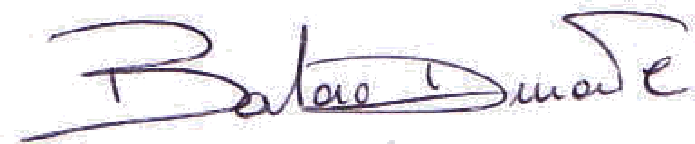
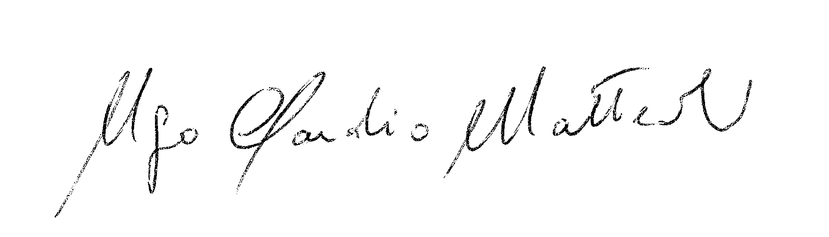
Ugo Claudio MATTEOLI Barbara DURANTE

